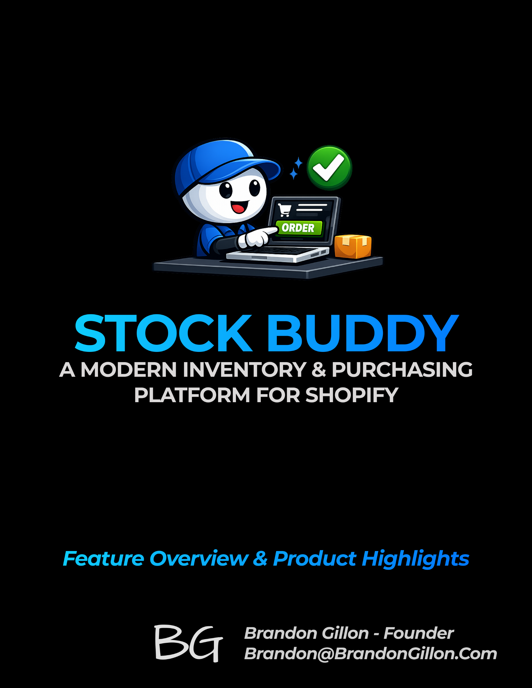

Introduction & Project-Level Guidelines

Thank you for participating in the Stock Buddy private beta. The goal of this beta is to validate real‑world workflows, identify confusing areas, and ensure the app behaves predictably before public release. Your feedback will directly shape the final product.
Purpose of the Beta
This beta focuses on clarity, reliability, and correctness.
- Validate core workflows in real merchant environments
- Identify confusing UI or unclear steps
- Confirm inventory and purchasing logic behaves as expected
- Surface bugs, edge cases, and unexpected behavior

What We Expect From Testers
No fixed testing schedule – use the app naturally.
- Use Stock Buddy in your normal workflow where possible
- Report anything confusing, unexpected, or incorrect
- Provide screenshots when helpful
- Try the suggested test scenarios (optional)

What Testers Can Expect From Us
- Clear communication about known issues and upcoming fixes
- Quick responses to reported bugs or blockers
- Regular updates during the beta period
- Transparency about what is and isn’t in scope

Tests Already Performed Internally
A summary of internal validation will be added here.
Suggested Test Plan (Optional)
A simplified tester‑friendly checklist will be added here.
How to Provide Feedback
A simple, consistent feedback method will be added here (e.g., form link, email, or shared workspace).

Project-Level Overview

Current Features
Stock Buddy currently includes the following capabilities:
Setup & Configuration
- Location Management – View and manage locations synced from Shopify
- Supplier Management – Add and edit suppliers; associate suppliers with products
Product & Inventory Foundation
- Product & Variant Sync – Pull product and variant data from Shopify
- Inventory Overview – View on-hand inventory levels across locations
- Incoming Inventory Tracking – Track quantities ordered, received, and remaining
Purchasing Workflow
- Purchase Orders – Create, edit, and manage draft and released POs
- PO Line Items – Add products, adjust quantities, and track incoming units
- PO Status Tracking – Monitor draft, released, and partially received POs
Exports & Communication
- PO Exports – Export purchase orders to CSV or PDF
- Automated Supplier Emailing — Automatically email purchase order CSV and PDF files to the supplier when the PO is released.
System Behavior & Sync
- Shopify Sync – Pull product, variant, and inventory data from Shopify
- Basic Error Handling – Alerts for missing or invalid data

Future Enhancements
Stock Buddy will continue to evolve based on real merchant feedback. Several areas are already being explored for future improvements, including:
- Enhancements to purchasing workflows
- Additional options for exporting or sharing purchase orders
- Expanded inventory insights and reporting
- More flexible supplier‑related tools
- UI refinements and workflow polish
- Additional automation where it adds clear value
These items are exploratory and may change as the product develops.

Known Limitations
Stock Buddy is still under active development, and some areas of the app are not yet complete. During the beta, you may notice:
- Certain workflows may require manual refreshes
- Some UI elements or screens may be incomplete or subject to change
- Error messages may be generic or not fully descriptive
- Some actions may take longer than expected as performance tuning continues
- Filtering, sorting, and search options may be limited in some views
- Some edge cases may not yet be handled
These limitations are expected during the beta period and will be refined as the product evolves.

Glossary
Term | Definition
Committed Inventory | Units allocated to open customer orders.
Draft PO | A purchase order still being edited and not yet sent.
Incoming Inventory | Units that have been ordered but not yet received.
Location | A physical or virtual place where inventory is stored (synced from Shopify).
On‑Hand Inventory | Units currently available in Shopify.
PO (Purchase Order) | A document used to order products from a supplier.
Released PO | A purchase order that has been finalized and sent to the supplier.
SKU | A unique identifier for a product variant.
Supplier | The vendor providing products for purchase.
Variant | A specific version of a product (size, color, etc.).

Screenshots (placeholder)
Screenshots with a label above each. (Width: 2.5–3 inches, Height: auto, Compression: 150–200 DPI (Word default ok)
Locations List | Suppliers List
Products List | Inventory Overview
Purchase Orders List | Purchase Order Detail
Dashboard | PO Export / Email Modal

Feature-Level Documentation

Locations
What This Feature Is
Shopify requires all inventory to be stored at a specific location. Stock Buddy syncs these locations directly from Shopify and uses them to organize on‑hand, incoming, and allocated quantities. Locations cannot be created or deleted in Stock Buddy — they are fully controlled in Shopify.
Where to Find It
Top header navigation → Locations
Key Capabilities
- Sync all Shopify locations using the Sync Locations button in the page header
- View all locations in a single list
- Click a location to open its detail page, showing address, type, Shopify ID, and metadata
- Add or edit contacts associated with a location
- Mark one contact as Primary (displayed on the main Locations page)
What to Test
- Confirm all Shopify locations sync correctly
- Verify location details (address, type, Shopify ID) match Shopify
- Add/edit contacts and confirm the primary contact displays correctly
- Check that inventory and PO allocations respect the correct location
Screenshots
Locations List – see Appendix A.1.1
Location Detail – see Appendix A.1.2

Vendors
What This Feature Is
Vendors in Stock Buddy come directly from Shopify’s field. Stock Buddy syncs these vendor names and uses them to group products and variants by brand or manufacturer. Vendors cannot be created or edited in Stock Buddy – they are fully controlled in Shopify.
Where to Find It
Top header navigation → Vendors
Key Capabilities
- Sync all Shopify vendors using the Sync Vendors button
- View all vendors in a searchable, filterable table
- Click a vendor to see all variants associated with that vendor
- Use the Columns dropdown to customize the variant table
- Click any variant to open its full details (covered in Section 3.3)
What to Test
- Confirm all Shopify vendors sync correctly
- Verify vendor → product/variant associations match Shopify
- Check for missing, duplicate, or unexpected vendor names
- Test search, filter, and export functionality on the vendor list
- Open a vendor and confirm the variant list is accurate and complete
Screenshots
Vendors List – see Appendix A.2.1
Vendor Detail – see Appendix A.2.2

Suppliers
What This Feature Is
Suppliers represent the companies you purchase products from. Unlike Vendors (which come from Shopify), Suppliers are created and managed directly in Stock Buddy. A supplier can provide products from one or many vendors, and each supplier has its own product list, CSV export rules, and email transmission settings for purchase orders.
Where to Find It
Top header navigation → Suppliers

Key Capabilities
Suppliers List
- View all suppliers in a searchable, filterable table
- Add new suppliers using the Add Supplier button
- Export the supplier list if needed
- Click any supplier to open its detail page

Supplier Detail Page (4 Tabs)
- General Info – Four cards containing core supplier information:
  - Supplier Basics — supplier number, name, lead days, payment terms
  - Contact Info — primary contact details
  - Address Info — supplier address
  - Internal Notes — internal‑only notes not sent to the supplier
- Product Data
  - Shows all variants currently linked to this supplier
  - Variants may come from multiple vendors
  - Columns dropdown for customizing the table
  - Edit button opens the supplier‑variant editor where you can:
  - Add variants to the supplier
  - Remove variants from the supplier
- CSV Overrides
  - Configure supplier‑specific CSV export fields
  - Overrides global CSV settings
  - Useful for suppliers with strict formatting requirements
- Transmission
  - Configure which email addresses receive PO emails
  - Add CC/BCC recipients
  - Choose whether PO emails include: CSV, PDF, or both
  - These settings directly affect PO release behavior

Add Supplier
- Opens a form to create a new supplier
- Populates the fields shown in General Info → Supplier Basics
- Supplier appears in the list after creation

What to Test
- Create a supplier and confirm it appears in the list
- Verify supplier details save correctly (name, lead days, payment terms, etc.)
- Add/edit contacts and confirm they display correctly
- Add/remove variants in the Product Data tab and confirm the list updates
- Confirm CSV override settings apply when exporting a PO
- Test Transmission settings by releasing a PO and verifying email behavior
- Check that suppliers can correctly link variants from multiple vendors

Screenshots

Suppliers List – see Appendix A.3.1
Supplier Detail (General Info) – see Appendix A.3.2
Supplier Detail (Product Data) – see Appendix A.3.3
Supplier Detail (CSV Overrides) – see Appendix A.3.4
Supplier Detail (Transmission) – see Appendix A.3.5

Products
What This Feature Is
The Products section provides a complete view of all Shopify products and variants synced into Stock Buddy. Products serve as the foundation for inventory, supplier associations, and purchasing workflows. Variants are the atomic unit used throughout the system — all inventory, supplier data, and PO line items operate at the variant level.
Where to Find It
- Top header
  - Navigation → Products
  - Dropdown options:
    - All Products
    - Supplier Data

All Products
Overview
Displays all products synced from Shopify, along with their associated variants. This view is primarily informational and helps testers confirm that product and variant data is syncing correctly.
Key Capabilities
- View all products in a searchable, filterable, exportable table
- Customize visible columns
- Click any product to open its detail page
- Review product‑level information and associated variants
Product Detail Page
- Product information displayed at the top (title, vendor, status, etc.)
- List of all variants belonging to the product
- Variant rows are currently read‑only (not clickable)
What to Test
- Confirm all Shopify products and variants sync correctly
- Verify product details match Shopify
- Confirm variant counts and variant attributes (SKU, barcode, options)
- Test search, filter, and export functionality
Screenshots
All Products List – see Appendix A.4.1
Product Detail – see Appendix A.4.2

Supplier Data
Overview
Supplier Data is where merchants associate supplier‑specific information to variants. This includes supplier SKU, supplier cost, case pack, MOQ, and other fields used in purchasing and CSV exports. This workflow is product‑centric and supports both manual entry and bulk CSV import.
Key Capabilities
- Landing page with two options:
- Manual Entry — add or edit supplier‑specific data for individual variants
- CSV Import — upload a CSV to bulk‑update supplier data
- Clear instructions and field definitions for CSV uploads
- Validation to ensure supplier data aligns with existing variants and suppliers
What to Test
- Navigate to Supplier Data and confirm both entry methods load correctly
- Add or edit supplier data manually and confirm it saves
- Upload a CSV and verify:
  - File is accepted
  - Mapping is clear
  - Data updates correctly
  - Confirm supplier data appears in:
  - Supplier → Product Data tab
  - PO creation
  - Supplier CSV exports
Screenshots
Supplier Data (Landing Page) – see Appendix A.5.1
Supplier Data (Manual Entry) – see Appendix A.5.2
Supplier Data (CSV Import) – see Appendix A.5.3

Inventory
What This Feature Is
The Inventory section provides a consolidated view of all variant‑level inventory synced from Shopify. Stock Buddy displays total available quantities across all locations and calculates incoming quantities based on open purchase orders. Inventory cannot be edited in Stock Buddy — Shopify remains the source of truth for on‑hand quantities.
Where to Find It
Top header navigation → Inventory

Key Capabilities
Inventory Overview (Landing Page)
- Displays a table of all variants synced from Shopify
- Inventory totals represent all locations combined
- Table actions include:
  - Search
  - Columns
  - Filter
  - Export
  - Pagination
Location‑Level Inventory
- Click the expand arrow on any variant row to view inventory broken out by location
- Each expanded row shows:
  - Location name
  - Available quantity at that location
  - Any incoming quantity associated with that location (if applicable)
Sync Inventory
- Use the Sync Inventory button in the header to pull updated on‑hand quantities from Shopify
- Sync updates:
  - Inventory Items
  - Inventory Levels
  - Location‑level availability
Incoming Quantities
- Incoming inventory does not come from Shopify
- Incoming is calculated entirely within Stock Buddy based on:
  - Open purchase orders
  - Quantities ordered
  - Quantities received
  - Remaining units not yet received
- Incoming totals are aggregated across all locations and displayed per variant

What to Test
- Confirm all variant inventory values match Shopify after syncing
- Expand variants and verify location‑level quantities match Shopify
- Create a PO and confirm incoming quantities update correctly
- Receive items on a PO and confirm incoming decreases appropriately
- Test search, filter, and export functionality
- Confirm pagination behaves correctly with large variant counts

Screenshots
Inventory Overview (with Expanded Location Info) – see Appendix A.6

Purchase Orders
What This Feature Is
Purchase Orders (POs) in Stock Buddy allow merchants to create, manage, release, and receive product replenishment orders. Stock Buddy owns the full PO lifecycle — from draft creation through release, supplier transmission, receiving, and closing — while Shopify remains the source of truth for on‑hand inventory. Incoming quantities are calculated internally based on open POs.
Where to Find It
Top header navigation → Purchase Orders

Purchase Orders List
Overview
- The PO landing page provides a complete view of all purchase orders, organized by status and filterable by supplier, location, and date range.
Key Capabilities
- Status tabs: All, Drafts, Released, Partially Received, Closed
- Table actions: Search, Columns, Filter, Export, Pagination
- Create PO button to start a new purchase order
- Click any PO to open its detail page
What to Test
- Confirm POs appear under the correct status tab
- Test filtering by supplier, location, and date range
- Verify search, export, and pagination behavior
- Confirm clicking a PO opens the correct detail page
Screenshots
Purchase Orders List – see Appendix A.7.1

Creating a Purchase Order
Overview
Creating a PO begins with selecting the supplier, location, and basic PO details. POs start in Draft status and can be edited until released.
Key Capabilities
- Enter supplier, ship‑to location, dates, notes, and line items
- Save Draft to create the PO
- After saving, the Release button becomes available
- Releasing a PO:
  - Updates status to Released
  - Sends the PO to the supplier using the supplier’s Transmission settings
  - Generates CSV/PDF files based on supplier configuration
What to Test
- Create a draft PO and confirm it appears in the Drafts tab
- Release a PO and confirm:
  - Status updates to Released
  - Supplier receives the email (CSV/PDF as configured)
  - Confirm incoming quantities update for all variants on the PO
Screenshots
Create Purchase Order – see Appendix A.7.2

Purchase Order Detail Page
Overview
The PO Detail page displays 100% of the PO’s information, including line items, supplier details, dates, notes, and status. All PO actions are available from this page.
Available Actions
- View History – Shows a timestamped log of all actions (creation, edits, release, receiving, cancellations)
- Cancel PO – Cancels the PO and removes incoming quantities
- Edit – Reopens the PO for editing (while still in Draft or Released, depending on your rules)
- Resend PO – Sends the PO again using the supplier’s Transmission settings
- Receive Items
  - Opens the receiving workflow
  - Enter received quantities per line item
  - Completing receiving:
    - Updates incoming quantities in Stock Buddy
    - Updates Available inventory in Shopify for the selected location
    - Moves the PO to Partially Received or Closed depending on remaining quantities
What to Test
- Open a PO and verify all details match the draft
- Edit a PO and confirm changes save correctly
- Release a PO and confirm email transmission
- Use Resend PO and confirm supplier receives it
- Receive items and verify:
  - Incoming decreases correctly
  - Shopify available quantity increases correctly
  - PO status updates to Partially Received or Closed
  - Review the History log for accuracy
Screenshots
Purchase Order Detail – see Appendix A.7.3
Receiving Items – see Appendix A.7.4

Dashboard
What This Feature Is
The Dashboard provides a high‑level operational snapshot of your inventory and purchase order activity. It highlights items that need attention, surfaces incoming replenishment, and offers quick access to common workflows. The Dashboard is designed to be simple, actionable, and fast — a place to understand “what’s happening right now” without navigating deeper into the app.
Where to Find It
Top header navigation → Dashboard

Dashboard Cards
The Dashboard contains four cards, each focused on a specific operational question.
Screenshot: see Appendix A.7.1
Low Stock
- Shows the 10 variants with the lowest available inventory across all locations.
- What it displays: Variant Title, SKU, Available Quantity, “Out of Stock” indicator when applicable
- Click behavior: Clicking the card takes you to the Inventory page.
- What to test:
  - Confirm the list matches the 10 lowest‑inventory variants
  - Confirm out‑of‑stock items are highlighted correctly
  - Confirm the card navigates to Inventory
Overdue Purchase Orders
- Shows purchase orders that are past their expected arrival date.
- Overdue logic: A PO is overdue if:
  - Status is Released or Partially Received, and
  - Expected Date is before today, and
  - Status is not Closed
- What it displays:
  - Total count of overdue POs
  - Top 2–3 overdue POs with:
  - PO number
  - Supplier
  - Expected Date (highlighted in red)
- Click behavior: Clicking the card takes you to the Overdue tab on the PO List.
- What to test:
  - Confirm only Released/Partially Received POs appear
  - Confirm Draft POs do not appear
  - Confirm the Overdue tab shows the same POs as the card
  - Confirm navigation works correctly
Getting Started
- Provides quick access to common workflows and setup tasks.
- What it displays: A list of helpful links, such as:
  - Create a purchase order
  - Receive items on a PO
  - Add a supplier
  - View inventory levels
  - Sync inventory from Shopify
- Click behavior: Each link navigates directly to the corresponding page or workflow.
- What to test:
  - Confirm each link navigates correctly
  - Confirm the list matches the expected workflows
Incoming Inventory
- Shows the total number of units currently incoming across all open purchase orders.
- Incoming logic: Includes POs in Draft, Released, or Partially Received status.
- What it displays:
  - Total incoming units
  - Top 2–3 incoming items with:
  - Variant title
  - PO number
  - Expected Date
  - Incoming quantity
- Click behavior: Clicking the card takes you to the Purchase Orders page.
- What to test:
  - Confirm incoming quantities match PO data
  - Confirm totals update after receiving
  - Confirm navigation works correctly

Settings
What This Feature Is
The Settings page allows you to configure global preferences for purchase order exports, email templates, and PO numbering. These settings apply to all suppliers and all POs unless overridden by future supplier‑specific settings.
Where to Find It
Top header navigation → Settings (gear icon)
Settings Tabs
The Settings page contains four tabs:
PDF Settings
Configure the appearance of the Purchase Order PDF export.
- What you can customize:
  - Logo Upload — Add your company logo to the PO PDF
  - Contact Information — Name, email, and phone number displayed on the PDF
  - PDF Preview — Shows a live preview of the PO layout
- What to test:
  - Confirm logo uploads correctly
  - Confirm contact info appears on the PDF
  - Confirm preview updates after changes
- Screenshot: see Appendix A9.1

CSV Settings
Configure the default CSV export for Purchase Orders.
- What you can customize:
  - Include/exclude optional fields
  - CSV delimiter (comma or semicolon)
  - Encoding (UTF‑8 or Windows‑1252 — future)
  - Column ordering (future)
- What to test:
  - Confirm toggles update the CSV export
  - Confirm delimiter changes are reflected in the downloaded file
- Screenshot: see Appendix A9.2

Email Settings
Customize the email sent to suppliers when a PO is released.
- What you can customize:
  - Email Subject Template
  - Email Body Template
  - Reply‑To Email Address
  - Reset to Default button
  - Preview Email button
- What to test:
  - Confirm subject/body changes appear in outgoing emails
  - Confirm reply‑to address is used correctly
  - Confirm reset restores default templates
- Screenshot: see Appendix A9.3

Purchase Orders Settings
Configure the PO numbering format and default values.
- What you can customize:
  - PO Number Format (prefix, separator, padding)
  - Next PO Number (editable with warning)
  - Default Expected Date Offset (used if no lead days exist on supplier)
- What to test:
  - Confirm PO numbers follow the configured format
  - Confirm next PO number increments correctly
  - Confirm default expected date is applied on new POs
  - Confirm default supplier/location populate correctly
- Screenshot: see Appendix A9.4
Appendix

A.1.1 – Locations List
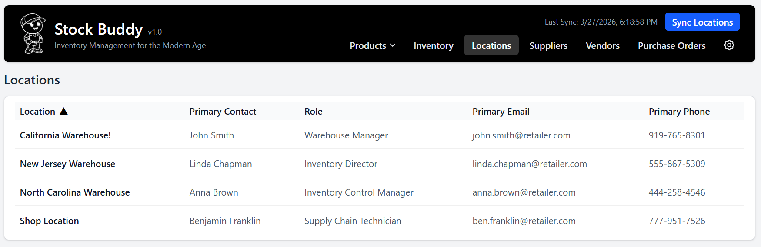

A.1.2 – Location Detail
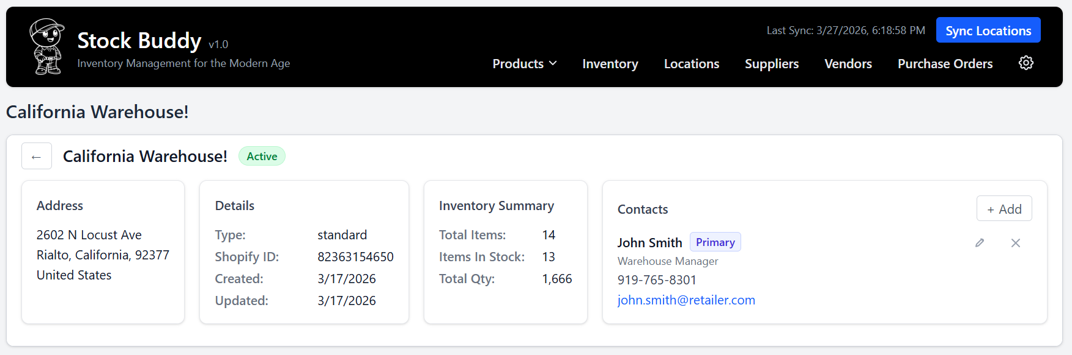

A.2.1 – Vendors List
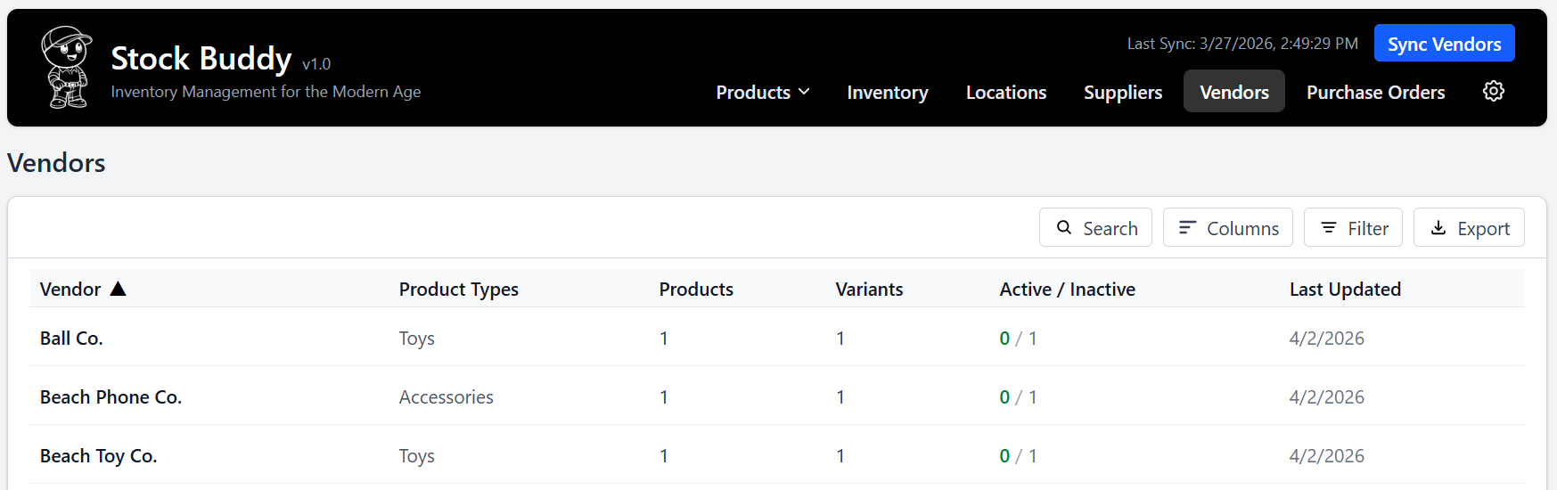
A.2.2 – Vendor Detail
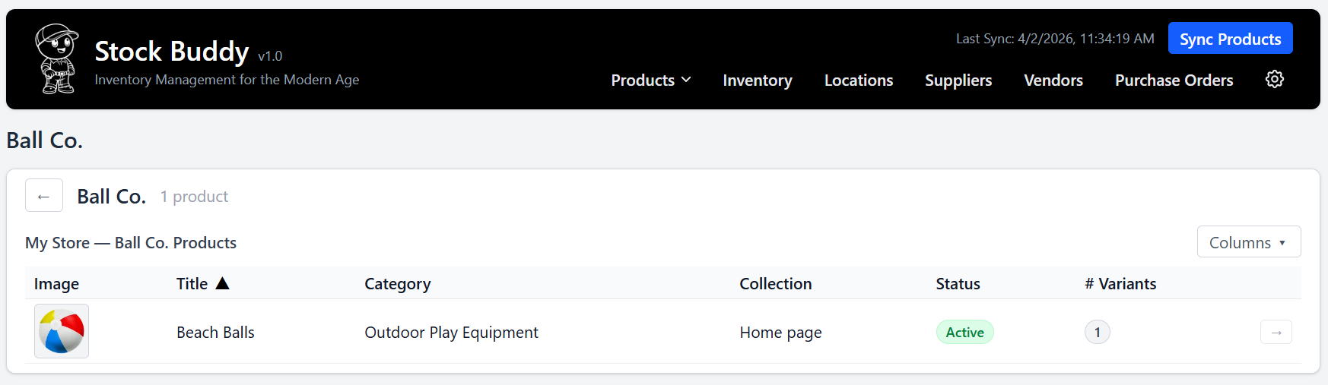

A.3.1 – Suppliers List
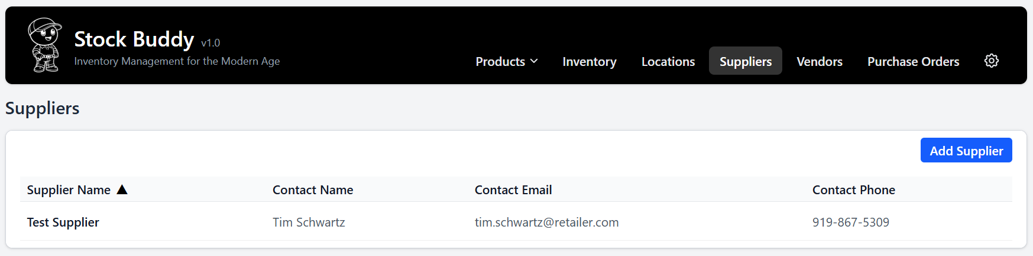

A.3.2 – Supplier Detail — General Info
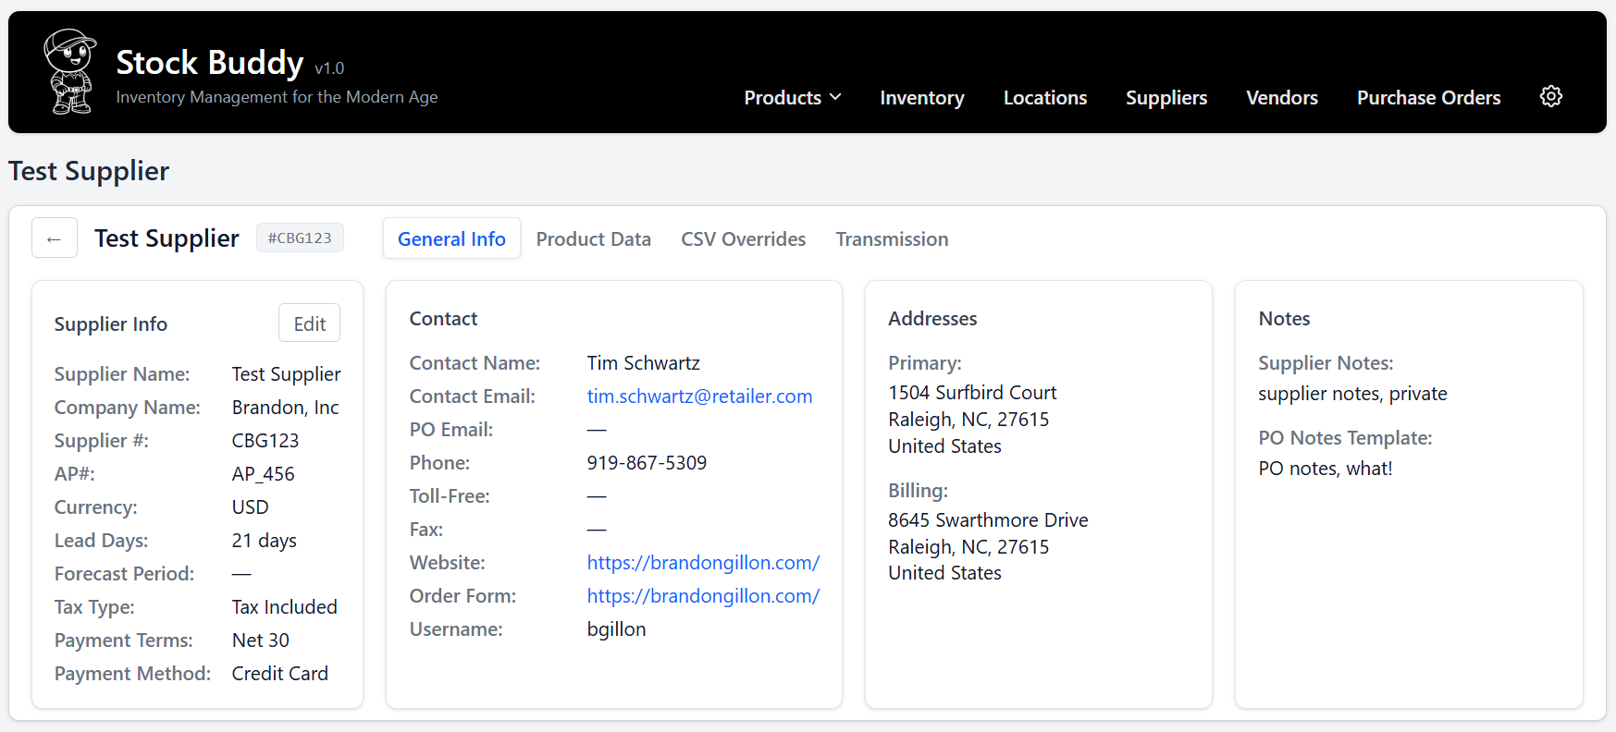

A.3.3 – Supplier Detail — Product Data
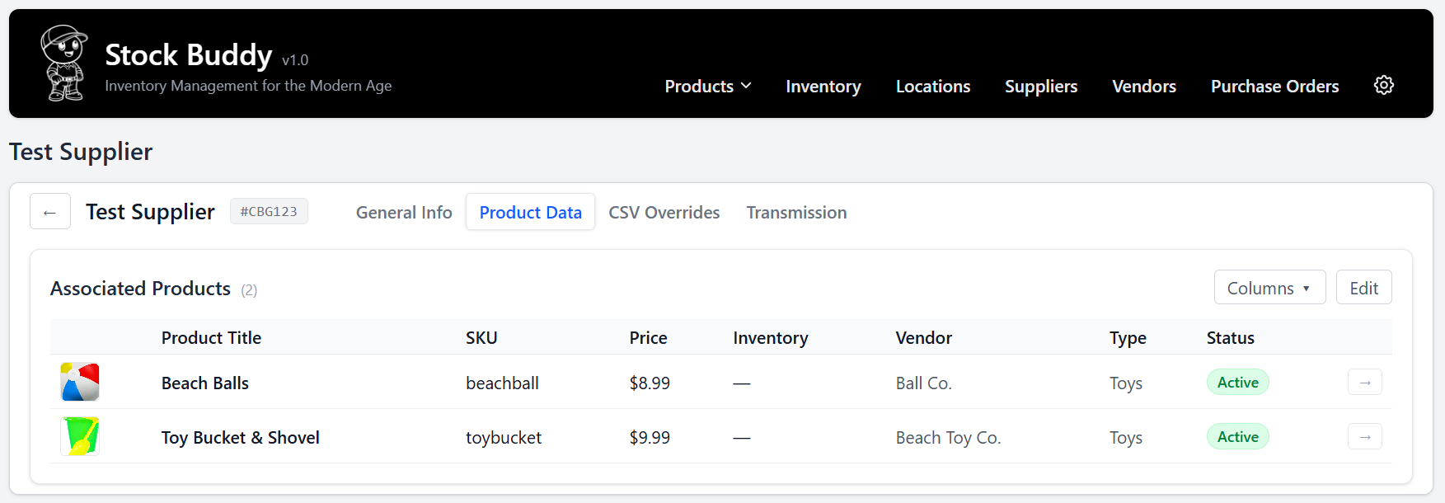

A.3.4 – Supplier Detail — CSV Overrides
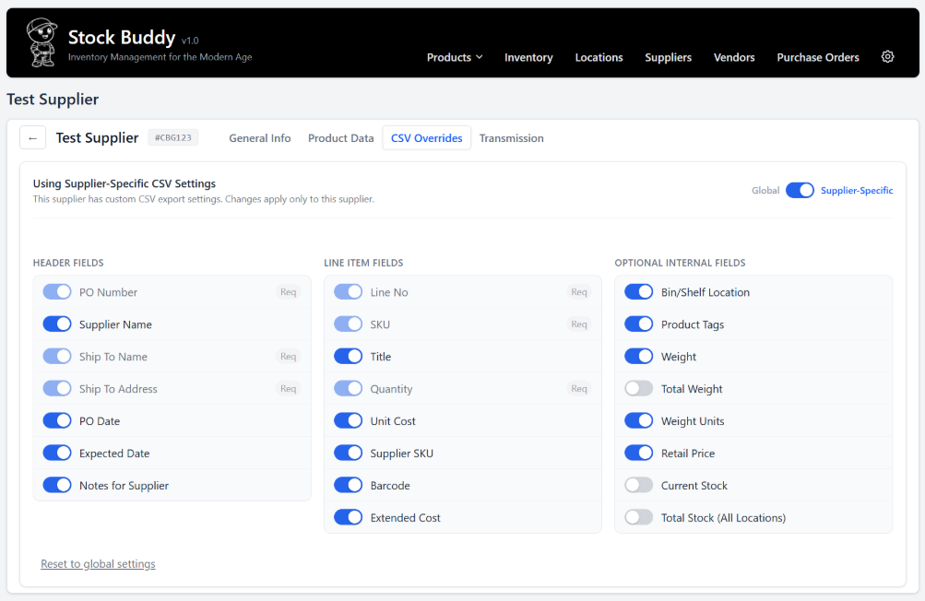

A.3.5 – Supplier Detail — Transmission
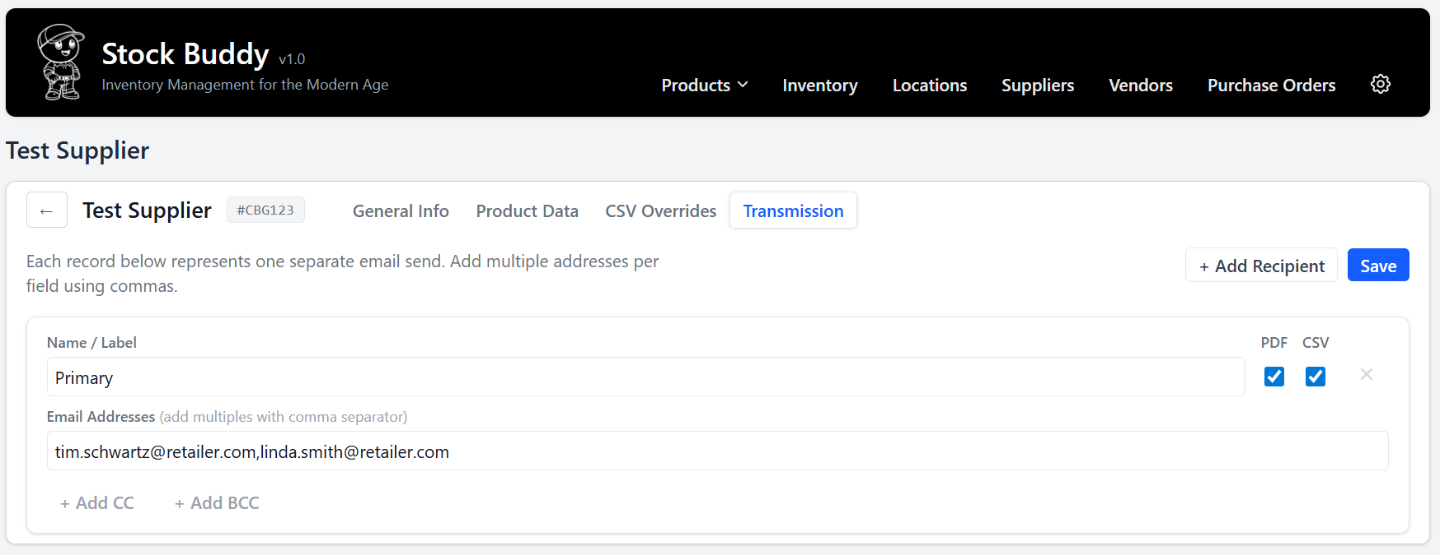

Appendix A.4.1 – All Products List
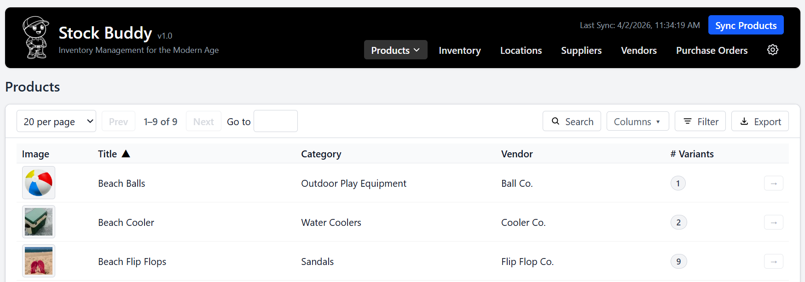

A.4.2 – Product Detail
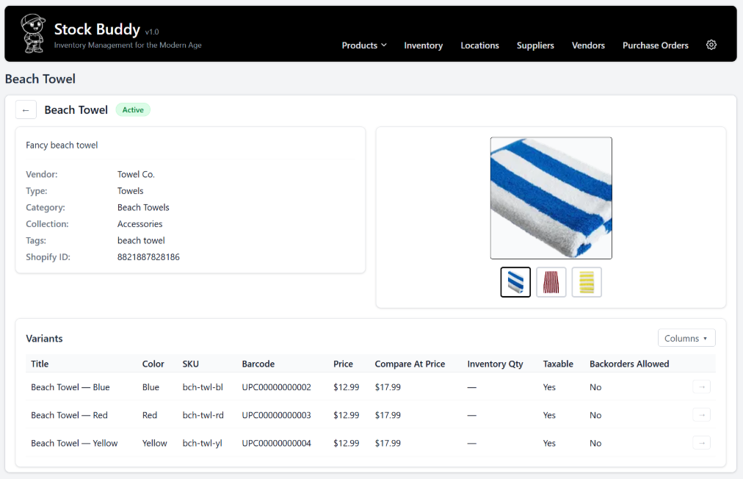

A.5.1 – Supplier Data (Landing Page)
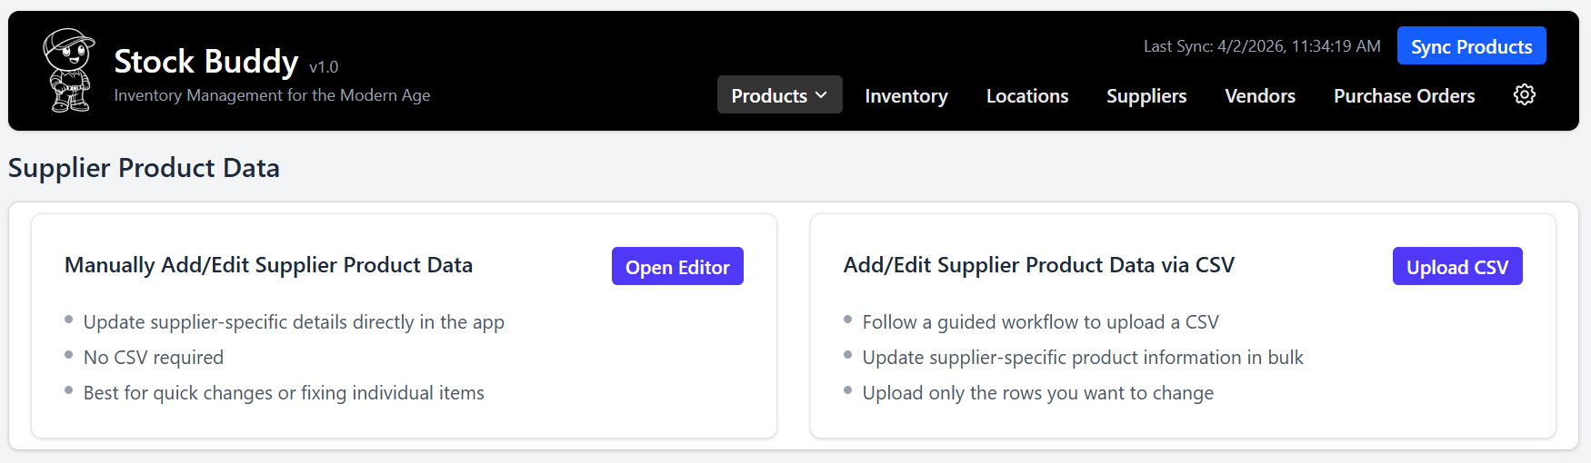

A.5.2 – Supplier Data (Manual Entry)
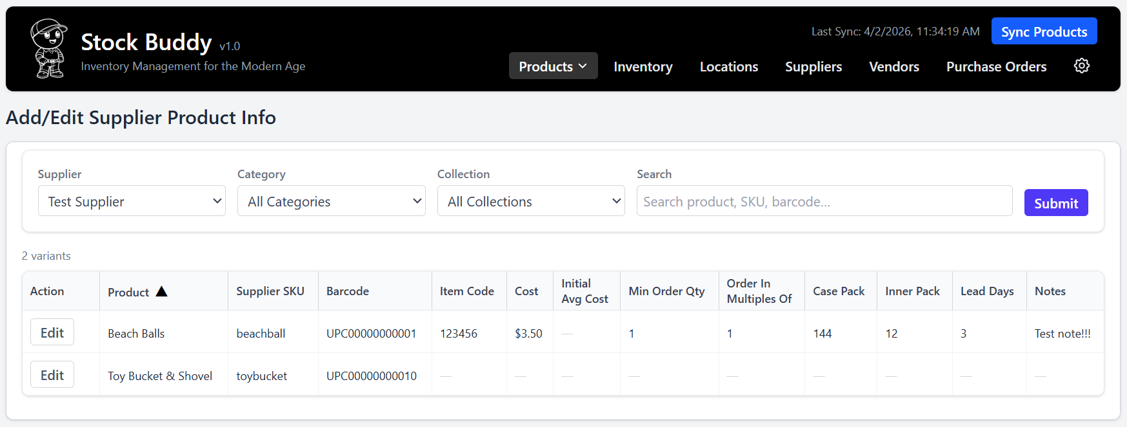

A.5.3 – Supplier Data (CSV Import)
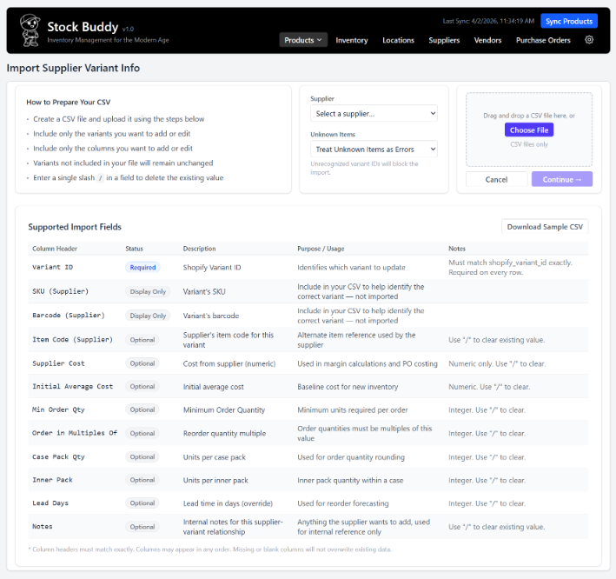

A.6 – Inventory Overview (with Expanded Location Info)
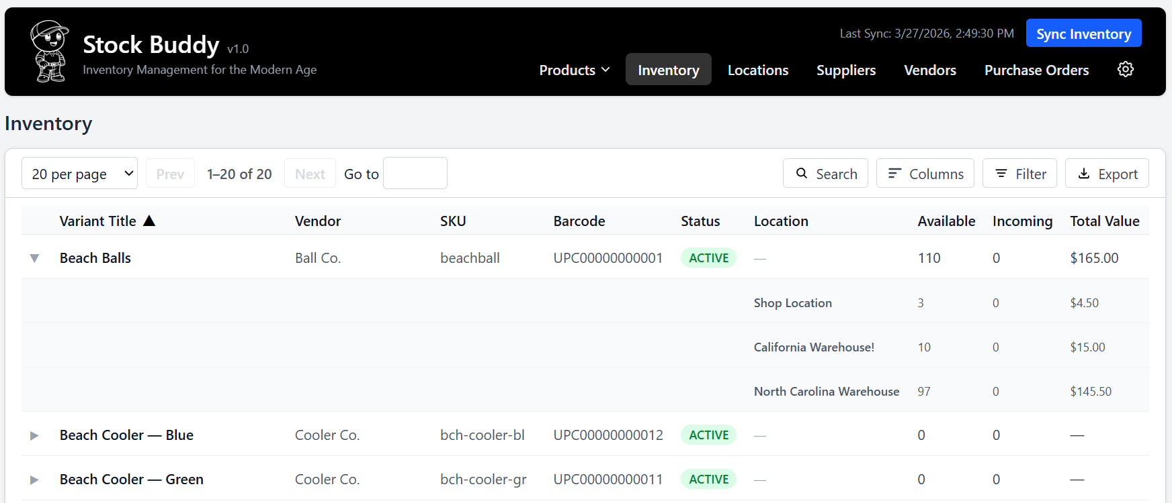

A.7.1 – Purchase Orders List
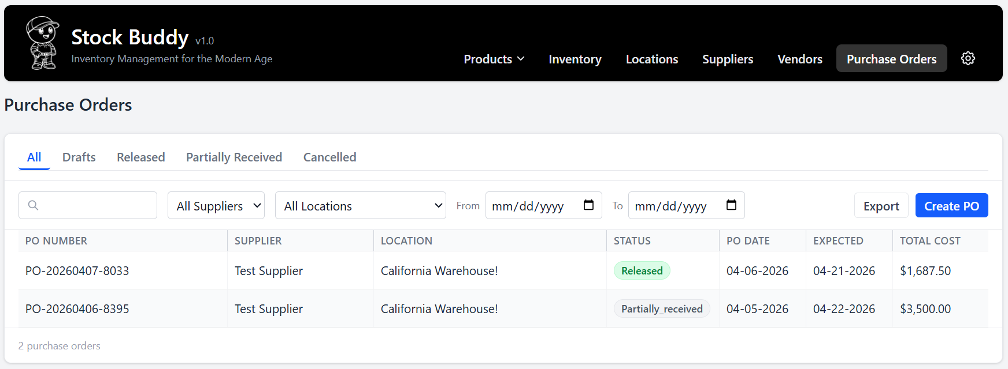
A.7.2 – Create Purchase Order
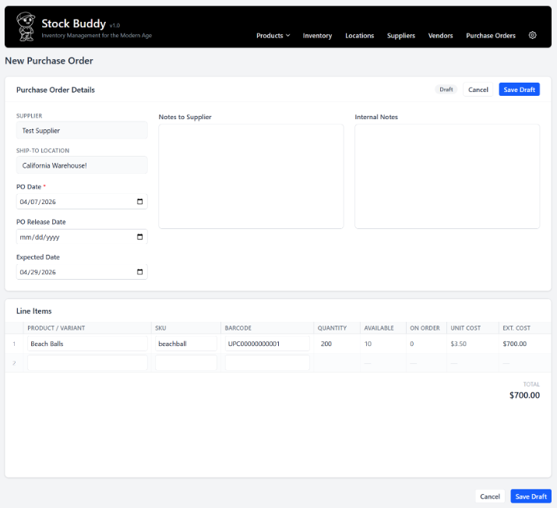

A.7.3 – Purchase Order Detail
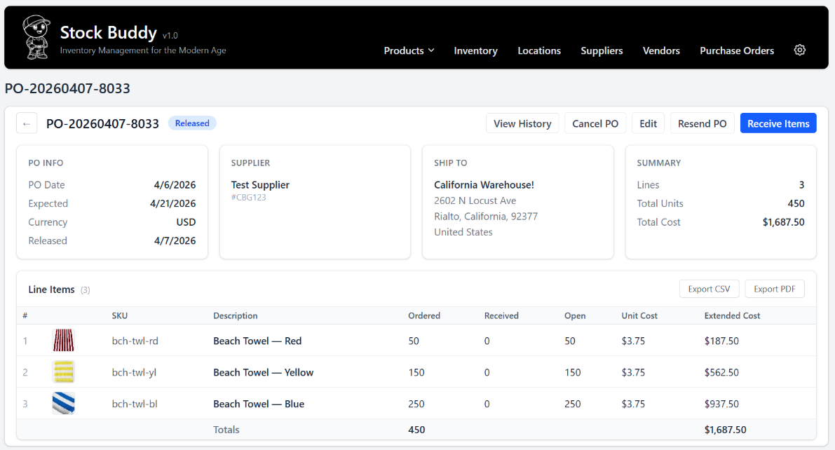

A.7.4 – Receiving Items
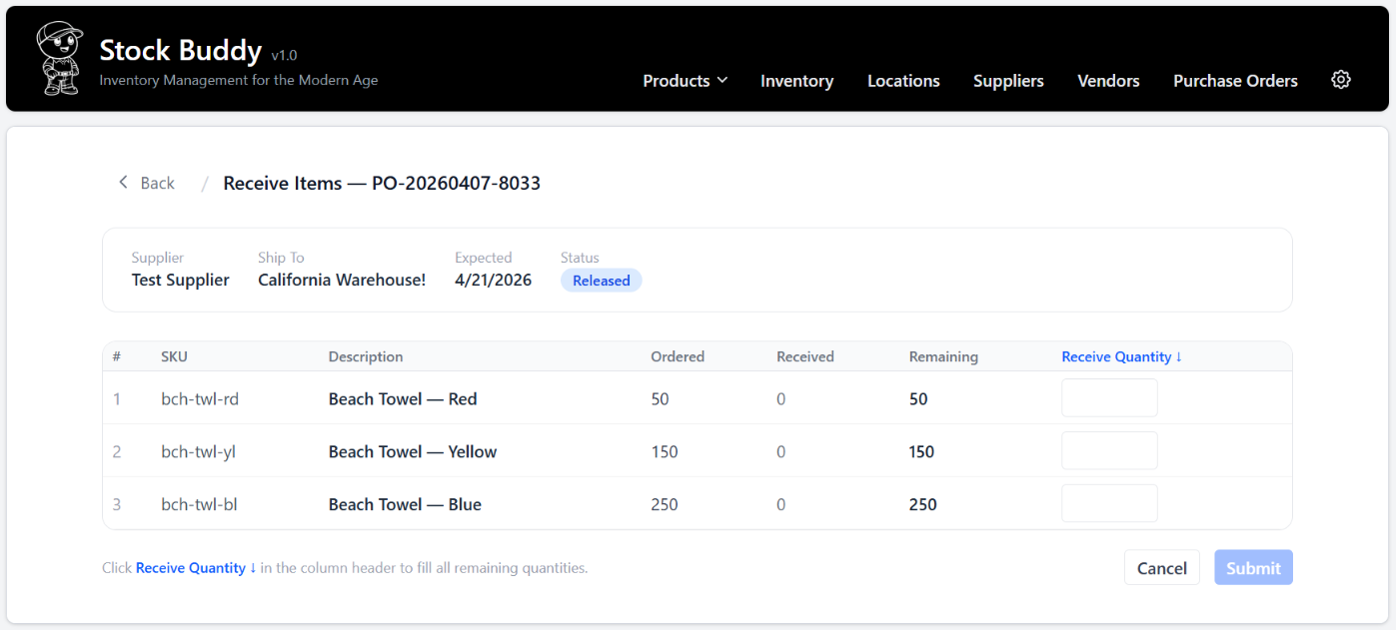

A.8 – Dashboard
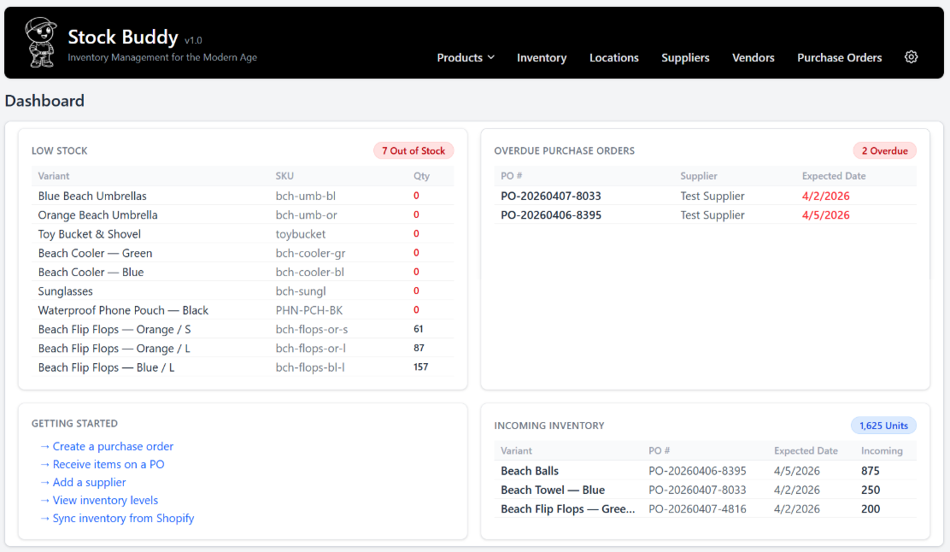

A9.1 – PDF Settings
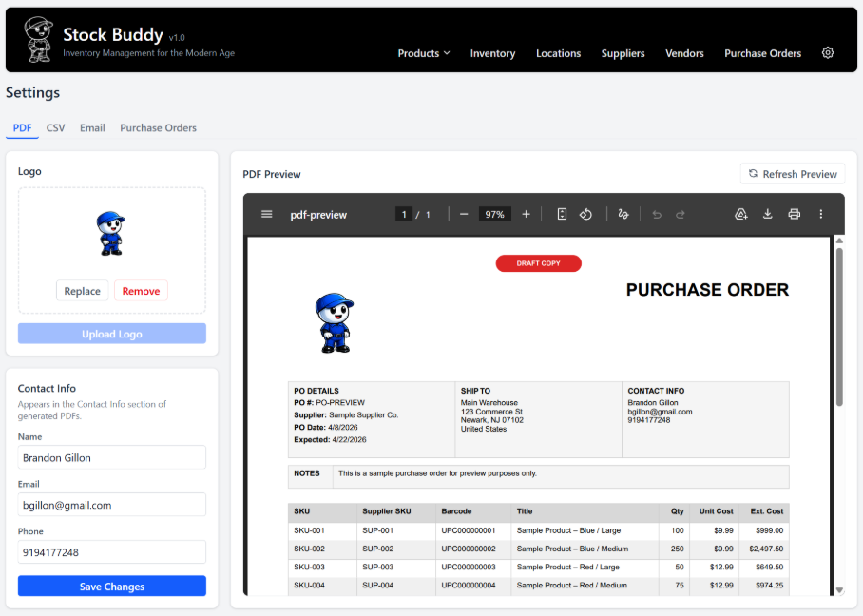
A9.2 – CSV Settings
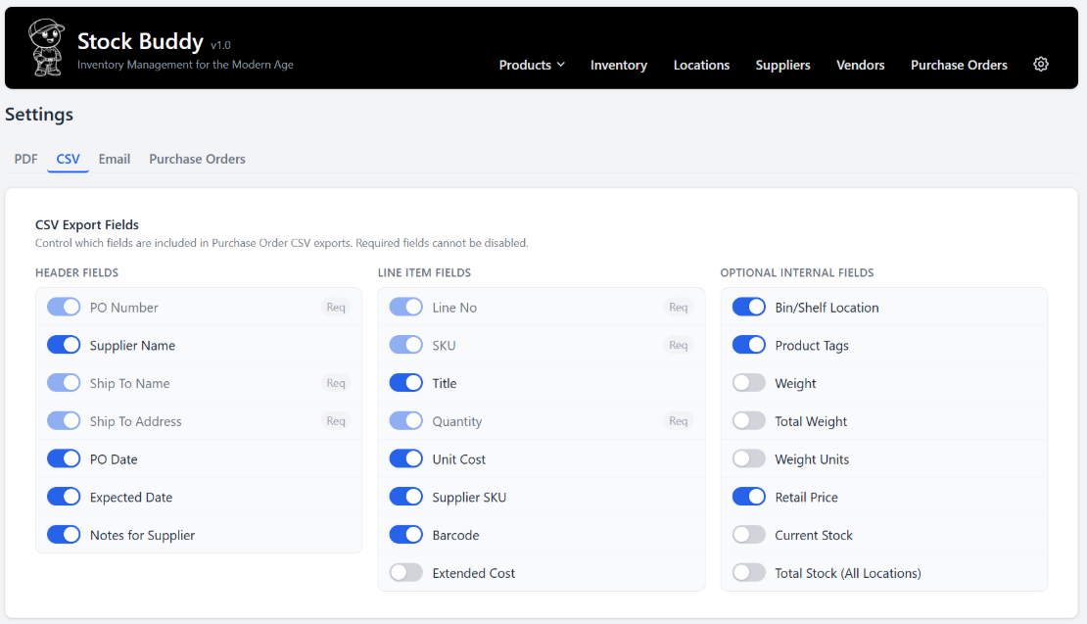
A9.3 – Email Settings
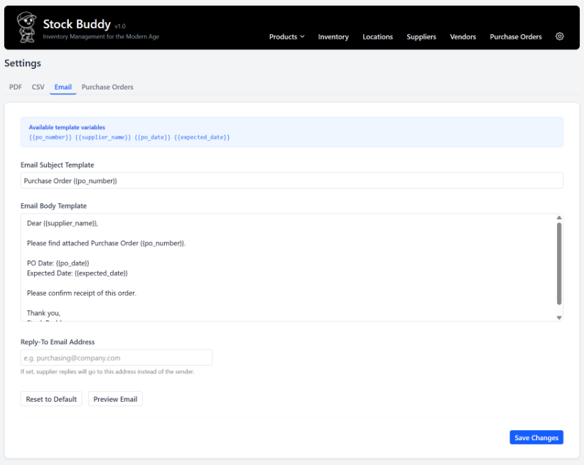
A9.4 – Purchase Order Settings


